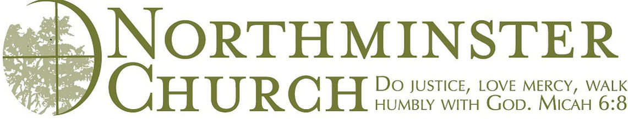

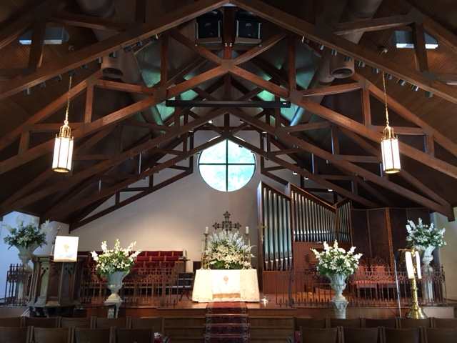

2701 Lamy Lane
Monroe, LA 71201
318-388-3717
www.northmin.org

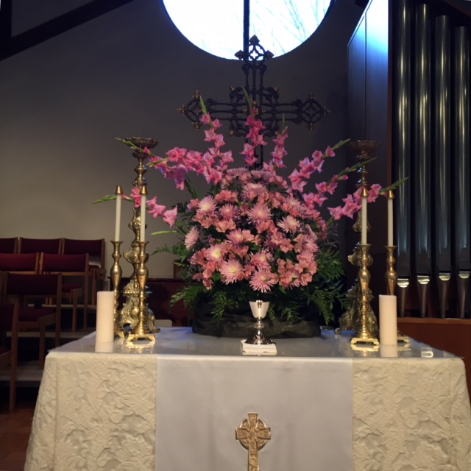

Table of Contents

Welcome to Northminster Church………………………………………………………………………….3
Our History…………………………………………………………………………………………………4
Regional Demographics……………………………………………………………………………………7
Church Demographics………………………………………………………………………………………9
Theology & Worship……………………………………………………………………………………...12
Governing Documents…………………………………………………………………………………….15
Mission Partners…………………………………………………………………………………………..18
Northminster’s Response to the Covid-19 Pandemic...…………………………………………………...21
Staff……………………………………………………………………………………………………….22
Governance……………………………………………………………………………………………….24
Our Future………………………………………………………………………………………………...25

Welcome to Northminster Church
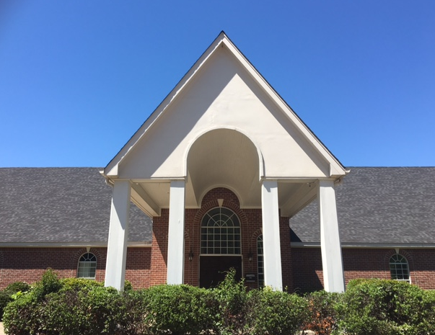
Northminster is a vibrant, inclusive community of faith located in Monroe, Louisiana. Through sacred scripture, awe-inspiring music, thoughtful litany, personal prayer and meaningful sermons, we give priority to the worship of God through the liturgical year. In times of study, we are a church which values hard questions over easy answers and wrestles with what it means to be a follower of Jesus in our 21st Century lives while delighting in the warm and open-hearted friendship of being together as God’s people. Yet our faith calls us to live outside the walls of the church through prophetic lives which relate to all people with compassionate sensitivity and generosity. We take seriously the scriptural call to do justice, love mercy and humbly walk with God to transform Christ’s world.

Our History
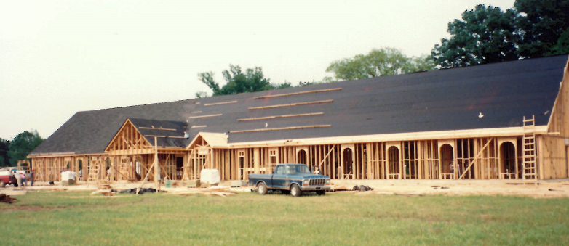
"This is a story about people finding a fellowship that is more like home than any ever dared to think was possible. More than that, it is a story about people who are home." – C. Welton Gaddy, Coming Home: For All Those Who Dream of a New Church.
​The First Years: A House Church and a Coffee Table
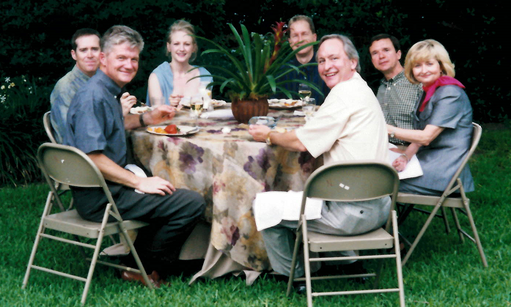
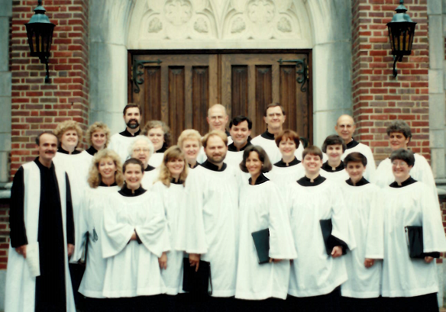
Northminster began around a coffee table. Sunday afternoon before Advent 1988, twenty-five to thirty friends met for worship in a home. There was no thought then of forming a church but simply of maintaining a fellowship of freedom-loving Baptists: free to worship, to minister, to be the people God was calling us individually (and, as it developed, collectively) to be. Through 1988 and into the early part of 1989 these friends and others who joined them continued to meet for worship in homes. By the second meeting there was a choir, anthems, hymns and beautiful worship. The coffee table became a communion table. As Northminster has gathered every Sunday since, the weekly celebration of communion has been a central part of our worship experience.

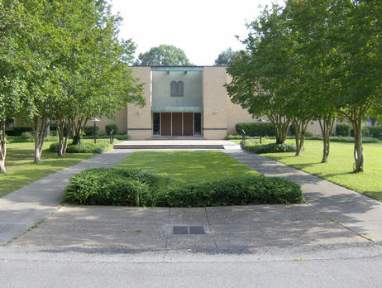
​ Jews and Baptists: The Hospitality of Temple B'Nai Israel

In early 1989 because we had outgrown the home in which we were meeting, we approached the congregation of Temple B'Nai Israel with a request to use their facility for worship and education. They agreed and thereby helped to birth not only a new church, but new friendships, new understanding, and a new awareness of what it means to be children of God. Our congregations continue to maintain a close relationship. In February 1989 we voted to form a church. We adopted a covenant, and in order to be inclusive to all we decided to call ourselves Northminster Church. In the spirit of our roots, however, our corporate name is Northminster Baptist Church.
We were officially chartered on Palm Sunday, March 19, 1989 with seventy-six founding members. In the spring of 1990 Northminster was denied membership in the Northeast Baptist Association because our membership is open to all Christians who find their baptism meaningful and because of the association's perception of Northminster's understanding of pastoral authority. Northminster Church has always been most closely affiliated with the Alliance of Baptists (a movement of progressive Christians - individuals and congregations - seeking to respond to the continuing call of God in a rapidly changing world), and in September of 1998 the congregation voted unanimously to withdraw from the Southern Baptist Convention.
​
Building a Church, Baptizing in the Bayou
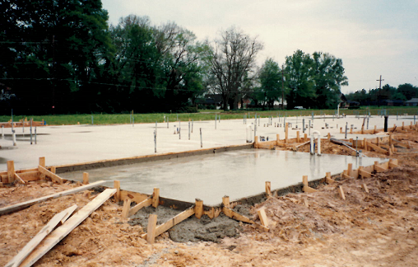
In December of 1989 Northminster purchased a 4.8 acre tract of land at the corner of Loop Road and Lamy Lane on Bayou Desiard in Monroe. Construction on a building to house the congregation began in April 1991. The building was dedicated on September 8, 1991 with Dr. Frank Stagg preaching the dedicatory sermon. Additional property was purchased in 1994, making the church's total property approximately 6 acres. Northminster has no baptistry; instead, we gather on the banks of Bayou Desiard for baptismal services.
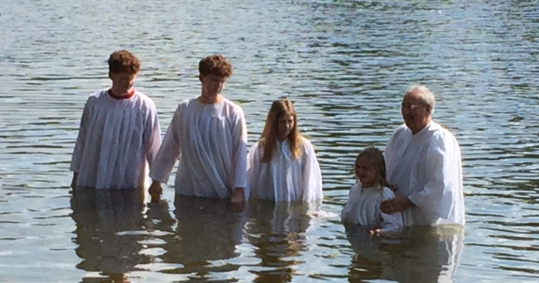

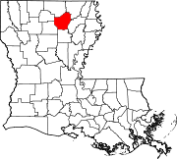
Regional Demographics
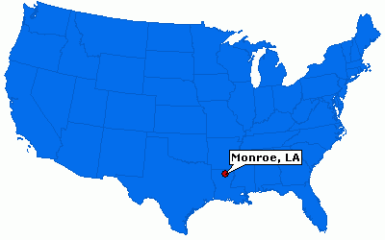
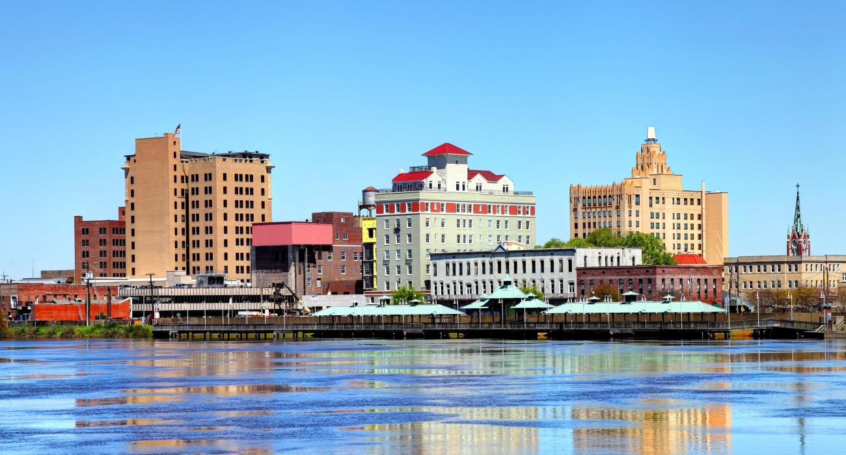

Ouachita Parish
Population in 2014: 156,325 (76% urban, 24% rural); it was 147,250 in 2000
Median age is 35
Housing
Owner-occupied with a mortgage or a loan houses and condos in 2010: 22,328
Owner-occupied free and clear houses and condos in 2010: 13,596
Owner-occupied houses and condos in 2000: 35,412
Renter-occupied apartments: 22,767 (it was 19,804 in 2000)
36% are renters / Louisiana average 33%
Income/Poverty
Average gross adjusted income of non-migrant taxpayers in 2010 was $47,416
Percentage of residents living in poverty in 2015: 23.3%
Employment
Educational, health and social services (16.8%)
Retail trade (14.2%)
Professional, scientific, management, administrative, and waste management services (14.1%)
Manufacturing (10.6%)
Finance, insurance, real estate, and rental and leasing (10.4%)
Types of Workers
Private wage or salary: 80%
Government: 7%
Self-employed, not incorporated: 12%
Unpaid family work: 1%
Racial Makeup
White Non-Hispanic Alone (59.6%)
Black Non-Hispanic Alone (36.4%)
Hispanic or Latino (1.8%)
Two or more races (1.0%)
Asian alone (0.9%)
Median resident age: 34.0 years
Louisiana median age: 35.0 years
Males: 74,776 (47.8%)
Females: 81,549 (52.2%)
Religion
Evangelical Protestant 64,281 / 163 Congregations
Mainline Protestant 11,018 / 30 Congregations
Catholic 10,152 / 7 Congregations
Black Protestant 8,908 / 35 Congregations
Other 2,071 / 9 Congregations (includes both Muslim and Jewish Congregations)
Orthodox 30 / 1 Congregation
None 57,260
Source: city-data.com

Church Demographics
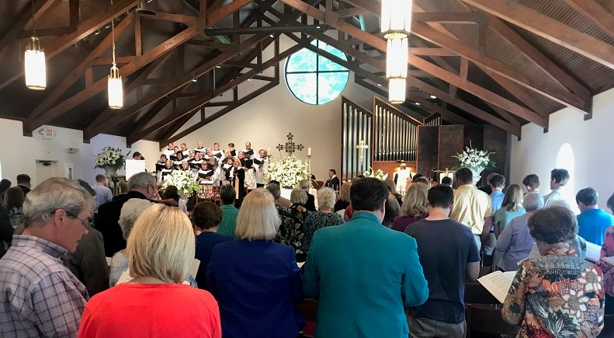

At Northminster Church, we are a lay led community of faith where everyone is considered a minister. As such, we value and welcome diversity within members, friends, and visitors. While no official records were kept historically, a census was conducted in 2018 with a heavy majority of participation. The results are as follows:
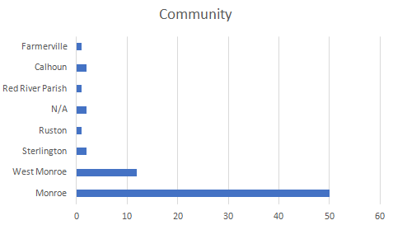
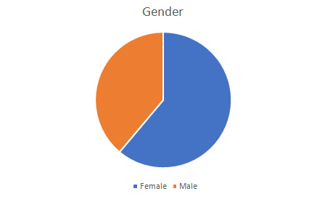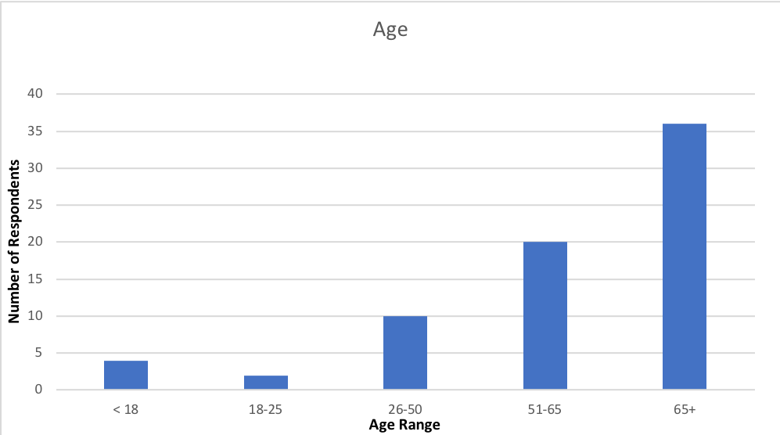
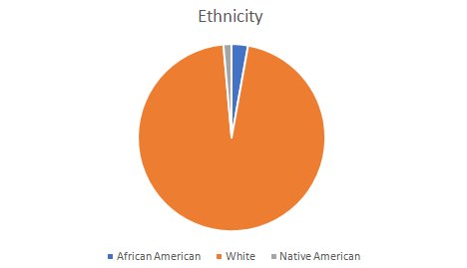
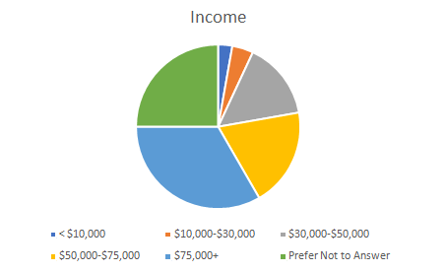
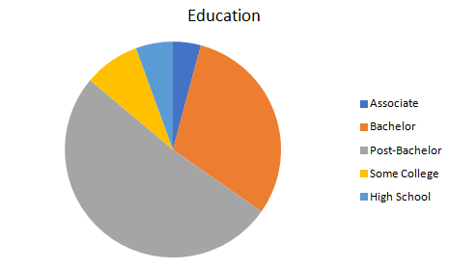
Total Membership | 260
Active Membership | 90
Average Worship Attendance 2017 | 84
Average Worship Attendance 2018 | 76
Average Worship Attendance 2019 | 86
Annual Undesignated Budget 2018 | $222,250 Receipts exceeded expenses
Annual Undesignated Budget 2019 | $242,354 Receipts exceeded expenses
Annual Undesignated Budget 2020 | $235,376 Expenditures exceeded receipts  by $455

Theology & Worship

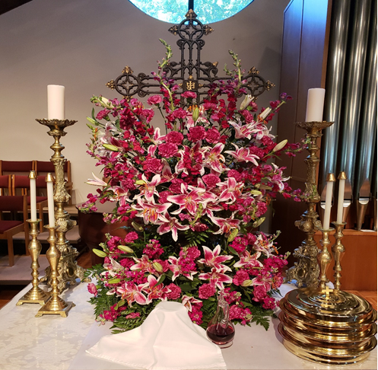
The Northminster Church family has developed a succinct set of core Values and Traditions. Congregants have come to embrace and revere these values which make Northminster such a unique house of worship in its region.
Inclusivity
Since our inception Northminster has welcomed, affirmed, and encouraged leadership and the sharing of personal talents from all persons regardless of gender, race, sexual orientation, social status, religious background or financial ability.
Worship Style
The Northminster “style of worship” consists of preludes at 10:45 am, 15 minutes before the start of formal worship. During this period, congregants are asked to enter the sanctuary for silent reflection during the musical offerings.
Worship begins with a processional led by a cross. The music offerings by the choir, organist, pianist and possibly other musicians are a mix of classical choral works and hymns, and occasionally have included secular selections, particularly from Broadway musicals. In addition, Northminster is a congregation that leans heavily toward liturgy- and lectionary-based worship.
Weekly worship is anchored by open Communion, preceded by the Lord’s Prayer. Congregants have made it abundantly clear that distributing Communion elements at every worship service gives them a constant reminder of God’s grace and love. The ritual includes the breaking of fresh bread (gluten-free wafers are also offered), a chalice of red wine, and individual cups of grape juice.
The congregation is additionally nurtured during annual special services, particularly during Holy Week, Christmas and Thanksgiving. The church’s Thanksgiving tradition of an Agape Meal in which members break bread together in the sanctuary and share personal stories of God’s influence in their lives through the instruments of preaching and fellowship.
These Values and Traditions combine with Northminster’s tradition as stated in its Covenant of the celebrating the freedom of the individual, led by God's Spirit within the family of faith, to read and interpret the Scriptures, relying on the historical understanding by the church and on the best methods of modern biblical study.
The Northminster Covenant further states that local church, under the authority of Jesus Christ, may shape its own life and mission, call its own leadership, and ordain whom it perceives as gifted for ministry, male or female.

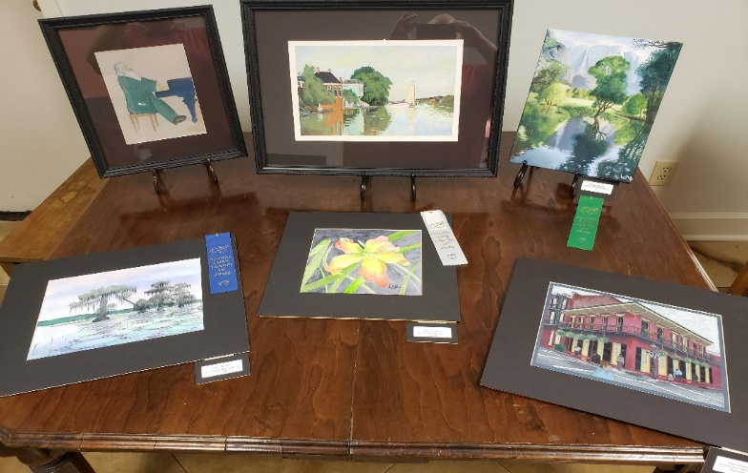
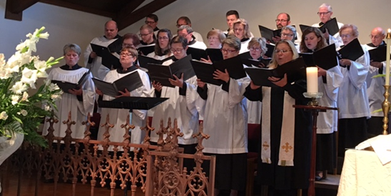
Music & The Arts

Very rightly the fine arts, by their very nature, are oriented toward the infinite beauty of God which they attempt in some way to portray by the work if human hands; they achieve their purpose of redounding to God’s praise and glory in proportion as they are directed the more exclusively to the single aim of turning men’s minds devoutly toward God.
Sacrosanctum Concilium, 122

Besides our unusually well-attended (for our church size) choir, we strive for quality of music as an expression of worship. Many Sundays, our music is written and/or arranged by our organist and musician in residence, Dr. D.H. Clark, also who wrote our church anthem, Sing Te Deum; while our director of music serves as the Director of Choral Activities at ULM (a local university); and our music associate, Justin Havard, also on the music faculty at ULM, is a multi-talented pianist, singer and director. The church is bursting with varied talent that is expressed in myriad ways, not just musically. We also value a heavy emphasis on the visual and performing arts including rotating art displays by local artists in our church narthex, as well as even the occasional production of theatrical plays directed by one of our many talented founding members who has her own local acting studio and directs community plays. A talented seamstress and founding member donated numerous beautiful hand-made paraments throughout the years, including a patchwork stole presented to Pastor Gaddy made entirely from fabric samples donated by congregants. We have tapestries and various visual presentations located in the church, some of which were acquired in Europe for the church by a founding member who is an interior designer. Northminster Church has also been blessed with several members who brilliantly arrange fresh flowers—as well as members who support the floral arrangements for various occasions and memorial floral presentations—that week after week help usher us into an often fragrant, but always beautiful, sanctuary environment where we are better able to seek the presence of God.

Governing Documents

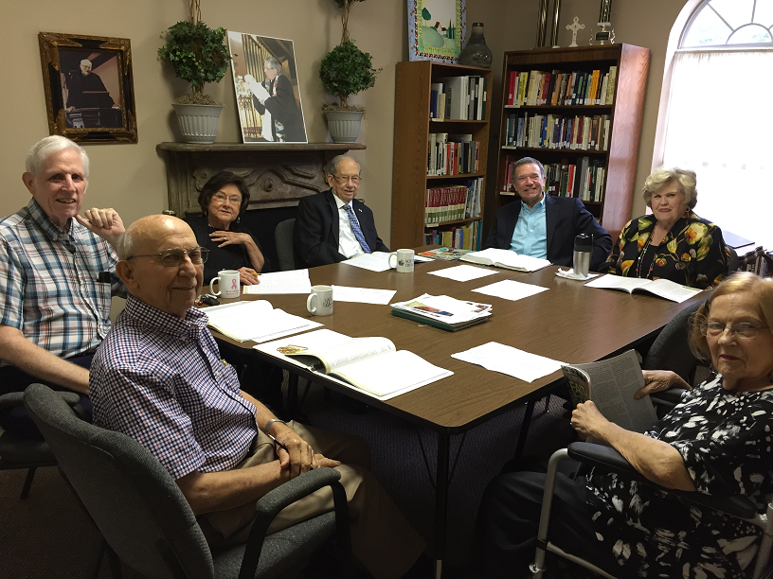

Northminster Church Covenant
The grace of God is making of us a fellowship to embody and express the Spirit of Christ. Therefore, we covenant together to love God with all our heart, mind, soul, and strength - to love each other as we love ourselves. We further commit ourselves to:
- The freedom of the individual, led by God's Spirit within the family of faith, to read and interpret the Scriptures, relying on the historical understanding by the church and on the best methods of modern biblical study.
- The freedom of the local church under the authority of Jesus Christ to shape its own life and mission, call its own leadership, and ordain whom it perceives as gifted for ministry, male or female.
- The larger body of Jesus Christ, expressed in various Christian traditions, and to cooperation with believers everywhere in giving full expression to the Gospel.
- The servant role of leadership within the church, following the model of our Servant Lord, and to full partnership of all of God's people in mission and ministry.
- Theological education in congregations, colleges, and seminaries characterized by reverence for biblical authority and respect for open inquiry and responsible scholarship.
- The proclamation of the Good News of Jesus Christ as revealed in the Gospels, and the call of God to all people to repentance and faith, reconciliation and hope, social and economic justice.
- The principle of a free church in a free state and to the opposition to any effort by either church or state to use the other for its own purposes.
From the Church Bylaws:
Article 2.
Mission
In the spirit of Christ, Northminster Church exists to serve as a tangible representation of the presence of God in Monroe, Louisiana and the surrounding community and to enable people to live as the children of God in the world. In faithfulness to this mission, Northminster Church commits itself to meaningful engagement in worship, education, missions, ministry, and fellowship.
A. Worship
Recognizing worship as the primary responsibility of the people of God, Northminster Church establishes the offering of substantive corporate worship as its highest priority. Northminster Church will offer a service of corporate worship each Sunday. Given the church’s belief in the priesthood of every believer, both clergy and laity will serve as worship leaders in experiences that involve the whole person even as the whole congregation in the worship of God. The incorporation of a variety of art forms, music, and preaching will contribute to liturgical services that blend with our Baptist heritage and historical worship practices that have been maintained in and passed on through the Christian church. Holy Communion will be served each Sunday.
B. Education
Acknowledging that serious Bible study is essential in enabling all of God's people to learn the substance of salvation history and the application of biblical truths for contemporary life, Northminster Church will offer programs of Bible study for all age groups. Additionally, Northminster Church will offer a variety of educational experiences to encourage personal Bible study, theological scholarship and spiritual formation. Christian education at Northminster Church will embrace both traditional and alternative methods of teaching and learning, drawing from religious leaders in the community and visiting lecturers.
C. Missions
Pledging, with God’s help, to meet the physical and emotional as well as the spiritual needs of people, Northminster Church will encourage every member of the congregation to identify with and participate in at least one particular mission involvement and provide, through its annual financial ministry plan, financial support for local, national and international missions approved for funding by a vote of the membership.
D. Ministry
Seeking to extend the healing ministry of Jesus in this community, Northminster Church will provide a program of ministries—such as counseling, prayer, visitation and crisis assistance—consistent with the needs of people in the community and the skills of laity and clergy within the church. The ministries of Northminster Church will be available to all who seek their benefit. Northminster Church commissions each of its members to participate fully in Christian ministry and calls theologically trained persons to help equip and enable members to realize their full potential as ministers.
E. Fellowship
Desiring to be a church characterized by nurture and care, Northminster Church will plan and maintain a variety of programs and activities aimed at building bonds of fellowship within its community. Both clergy and laity will sensitively seek to incorporate new members into the fellowship, create mutual respect and understanding among all members, and offer personal attention and special assistance to members in times of unique need. As a church appreciative of its strong Baptist heritage and committed to historic Baptist distinctives, Northminster Church values ecumenical relationships and welcomes into its fellowship persons of varied theological and denominational backgrounds.

Mission Partners
We believe a mission is not a mere list of things to do; rather, it is something we live as followers of Jesus. Thus, our mission as people of faith in Christ is to tend to the physical needs of people just as much as the spiritual needs of people and enter into co-creative, co-operative relationships with those on the margins of society. At Northminster, we seek to partner with organizations, churches and individuals who join us in the ongoing work of mercy, justice and love and who help us live as authentic followers of Jesus. We look for opportunities in which we can partner, collaborate and create with others the kingdom of God here on earth.
Cuba Partnership

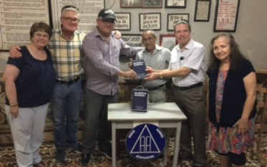
In 1994 Northminster entered in a partner church relationship with Iglesia Bautista Enmanuel (Emanuel Baptist Church) in Ciego de Avila, Cuba. This is one of about 30 such partnerships between churches of the Alliance of Baptists and churches in the Fraternity of Cuban Baptist Churches. At least annually since 1994 Northminster members have traveled to Cuba for dialogue and fellowship and to participate in worship with members of Enmanuel and its several mission congregations. On each trip our members have also carried needed medicine, clothes and other items. Northminster makes a yearly financial contribution to Enmanuel to assist in its ministries. We have also helped Enmanuel pay a short-term debt on the house which serves as their worship and educational center, have provided financial support for Enmanuel students attending the ecumenical seminary at Matanzas, and have helped support the purchase of property next door to the church and renovations and additions to the building. At Northminster’s invitation and with our support several members of Enmanuel have visited us from time to time. This is a partnership of mutual respect and support, and we are richer for our relationship with our sisters and brothers in Cuba.

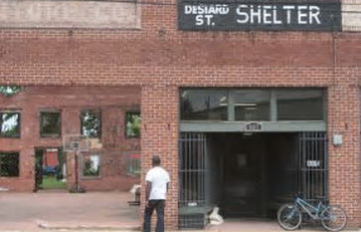
DeSiard Street Shelter
The 5th Saturday of any month different groups from Northminster Church gather to cook and serve breakfast at the Desiard Street Shelter downtown. We go in teams of three. One of the three is a coordinator, who is responsible for contacting the other two members of the team, as well as facilitating the shopping, cooking, and serving.

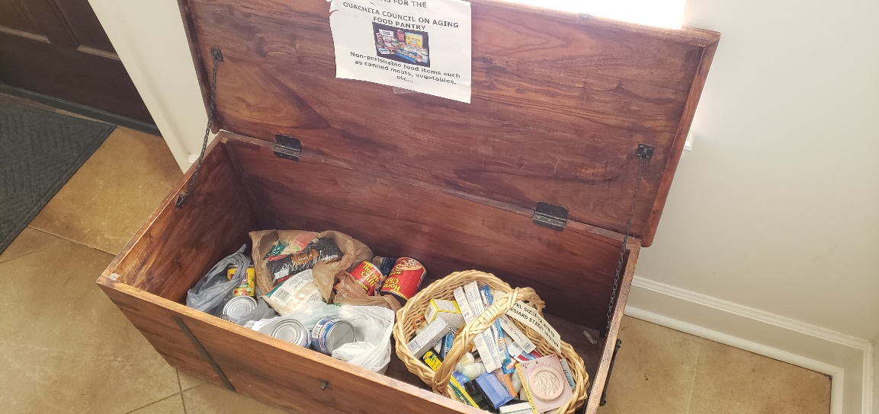
Missions Trunk in Narthex
Each month a new charity is represented on the Missions Trunk in the Narthex. Northminster members are very generous in providing for the needs of our various charitable organizations.

CMinistry to Immigrant Detainees
Within the past few years, immigrant detainees have arrived and been housed at a private detention facility near Monroe. Several of our members have become involved with others in our community to reach out and provide support to these detainees. More recently more and more detainees have been released to family members and friends in the country. When this occurs, our members have also been involved with providing transportation from the detention facility to a hotel (and the cost of the hotel) and to the airport or bus station, meals and clothes, toiletries and cell phones when necessary.

Racial Justice Working Group
Under the leadership of our former co-pastors Claire and Zach Helton several book studies were held on the subject of racial justice and a racial justice working group has been formed and working within Northminster. Northminster’s denominational partner, The Alliance of Baptists, is committed to and actively working toward becoming an antiracial organization. The mission of Northminster’ racial justice working group is to create a space at Northminster for intentional conversation around racial justice by: (1) engaging in continual education of ourselves and our congregation, (2) fostering relationship across racial and ethnic lines and (3) supporting the direct action of our members in the areas of racial justice. The pandemic has slowed the work of this group, but hopefully the group can become more engaged as we emerge from the pandemic.
Budgeted Missions
National & International
- Sister Church – Cuba
- Alliance of Baptists
Local Missions
- Habitat for Humanity
- DeSiard Street Shelter
- Meals on Wheels
- Food Bank
- Med Camps
- St. Vincent DePaul
- Benevolent Fund (for non-members)
- Church Crisis Fund (for members)

Northminster’s Response to the Covid-19 Pandemic
In March of 2020 because of the COVID-19 pandemic we closed our building. Thanks to the excellent leadership of our co-pastors Zach and Claire Helton and our music staff, Debi Chandler, DH Clark and Justin Havard, we continued to have meaningful worship experiences online via YouTube. Prior to each service there was a lively chat room and visiting via Zoom following each service. Adult Sunday School classes, church business meetings, commission meetings and other group meetings and book studies were held via Zoom. Each week Sunday School materials were physically delivered to our children by church members. As best as we could under the circumstances we continued to reach out and minister to one another and to our larger community. Our online worship services were not only viewed by our local members and friends but also by former members and others from numerous places in the country. During the pandemic a few of our on-line services had more than 250 views, some more than 200 and even more over 150. Most services had more than 100 views. Pre-COVID our in-person worship attendance was rarely more than 100, thus indicating a wider audience at times.
Our YouTube channel also allowed us to venture out in other ways. Two “Northminster Has Talent” online shows were presented with one garnering 184 views and the Christmas talent show 250 views. Northminster’s Arts Commission presented two art exhibits, one with 256 views and the other 111. During the two Holy Weeks we were not physically present in the church building daily online devotions were well viewed as were the evening Maundy Thursday and Good Friday services. Northminster’s Thomas Stricklin Lectures in Church History were presented online by Dr. Welton Gaddy on the theme “Religious Freedom, Our First Freedom: Stories of Liberty” to a wide audience. Videos of these services and presentations can be viewed on Northminster’s YouTube channel where they are saved.
We returned to in-person worship on Pentecost Sunday, May 23, 2021. While not surprisingly our in-person worship numbers have not returned to their pre-pandemic levels, our online viewing has remained robust. After some initial hiccups caused by a steep learning curve, we are now streaming our worship services weekly, and videos of the services are available on our YouTube channel. With all of the negatives of the pandemic, because of our online capabilities, we have found that there is a wider, interested audience out there for our progressive church. We look forward to pursuing how we can further expand this audience as we live into our future.

Staff

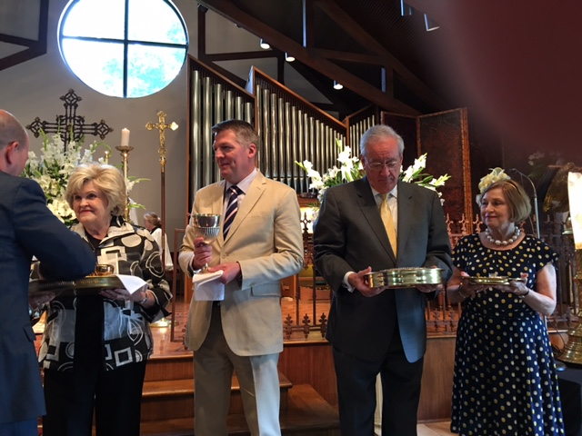
Previous Clergy
Since the beginning, Northminster has had strong lay leadership, and initially did not call a pastor. We were (and are) in Carlyle Marney's term "priests to each other." For our first three years we were fortunate to have a host of talented persons fill our pulpit. Don and Cathe Nixon were our first ministers, Don serving as Minister of the Arts and Cathe as Director of Christian Education. Don established an outstanding choral music and arts program that continues to this day. In the spring of 1992 the congregation decided to move forward with a search for our first pastor. Dr. C. Welton Gaddy preached his first sermon as pastor on the first Sunday of Advent, 1992. In March 1998, Dr. Gaddy became the executive director of Interfaith Alliance headquartered in Washington, D.C. He remained at Northminster as Pastor for Preaching and Worship. The Gaddys maintained their home in Monroe, and Dr. Gaddy commuted to Washington to carry out his responsibilities with the Alliance. During Dr. Gaddy’s tenure with Interfaith Alliance associate pastors were called to provide pastoral care, administration and other ministerial functions in Dr. Gaddy’s absence. Those serving in that capacity were Jim Evans, Joanne Juett, Carl Gregg and Claire McKeever-Burgett.
In 2014 Dr. Gaddy retired as president of Interfaith Alliance and in October 2016 he retired from the Northminster pulpit and was named Pastor Emeritus. For almost two years Dr. Steve Jolly served as Intentional Interim Pastor as he led us in a discernment process concerning our future prior to calling a new pastor. In December of 2018 Rev. Claire and Rev. Zachary Helton were called and began serving as our co-pastors. In June of 2021 they announced that they were returning to school and would be pursuing new career paths.

Current Clergy
Pastor Emeritus
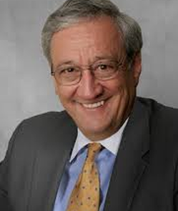
Dr. Gaddy was senior pastor at Northminster for over 24 years, retiring in 2016. He is also the former president and now President Emeritus of Interfaith Alliance. Dr. Gaddy is the author of over 20 books and hosts “State of Belief” on Air America Radio.
Rev. Dr. C. Welton Gaddy

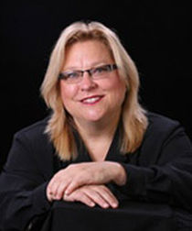
Director of Music
Dr. Chandler is Director of Choral Activities at the University of Louisiana at Monroe. She is also musical director and conductor of the Bayou Masterworks Chorus, the Louisiana Lyric Opera, and is the host of “Vocal Vibes” on local public radio station 90.3 FM KEDM.

Dr. Deborah Chandler

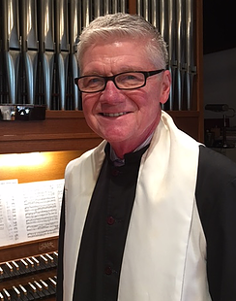
Organist and Musician in Residence
A founding member of Northminster, Dr. Clark began serving as the Director of Music in 1997. He has enriched services at Northminster with many original compositions and arrangements. He serves as organist at our beautiful 15 rank Möller and he has served as organist at local churches historically while founding local mass choirs. He recently retired from the Woman’s Clinic of Monroe, where he was a OBGYN physician for 30+ years.
Dr. D. H. Clark
Music Associate
Justin Havard is an accomplished director, pianist, and singer who has spent the last 13 years making music in the Tampa Bay area. Originally from Mobile, Alabama, he received his Bachelors and Masters Degrees in Choral Music Education from Florda State University with an emphasis on piano. He was the collaborative pianist for the Florida All-State Men’s Choir in 2017 and 2018 and he has played for many national tours including The Book of Mormon, Wicked, and Spamalot.
Mr. Justin Havard

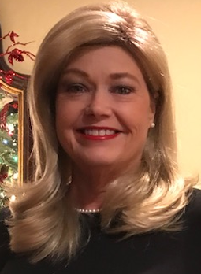
Administrative Assistant
Renee Decker is very proficient in all computer skills, the running of the church office and assisting the staff and Coordinating Council Chair as required. She enjoys playing hand bells at First United Methodist Church in Bastrop. Renee also sings, plays trumpet and percussion with “Reily and Friends” and “Homegrown,” a bluegrass, country, and gospel band.

Renee Decker

Governance

Coordinating Council

​The Coordinating Council is a nine-person governing body, headed by an elected Chair who serves as the Chief Executive Officer of the church. The Council leads the church in a fellowship of worship, witness, education, ministry, and missions. The Council also manages the business and financial affairs of the church, as well as other matters the congregation delegates to it. Members are elected for a three-year term. The business meetings of the church serve as the final authority on all decisions and the congregation meets bi-monthly for this purpose.

Church Commissions

Arts Outreach
Columbarium Properties
Education Hospitality
Family Ministries Stewardship
Missions Worship

Our Future
Hopeful. Expectant. Optimistic. Committed. These are some words that describe the Northminster congregation as we look toward our future. As a relatively small band of mostly renegades, our short but significant past should be the prologue for promising times to come. As we begin to emerge from the pandemic, we are fortunate that our core has remained strong. We look to build on the strength as we seek to reach out to others in our local community and now our larger Internet community- others who with us want to “do justice, love mercy and walk humbly with our God”. We seek to find a pastor eager to travel with us on this journey. May it be so.

